Thamica Tertulien
EQUIPOTENTIAL SURFACES

EQUIPOTENTIAL SURFACES
OBJECTIVE:
The main objective of this experiment is to study the relationship between the electric field lines and the equipotential surfaces along with some cases of two point charges of opposite charges and cases of oppositely charged parallel conductor plates.
PRINCIPLES:
All charged objects have an electric field that radiates from the object.
However, electric fields are never measured directly. Instead, another property, called the electric
Potential difference (voltage) is measured. For this procedure, the voltage was measured between one positive charge and one negative charge. Measuring the voltage between the two charges is how to find equipotential lines, which are lines where the voltage remains the same.
Equipotential lines then provide the path of the electric field lines since they are perpendicular to one another. Using the distance between each equipotential line and the positively charged plate,
the value of the electric field can be determined by dividing the voltage by the distance
All charged objects have an electric field that radiates from the object.
However, electric fields are never measured directly. Instead, another property, called the electric
Potential difference (voltage) is measured. For this procedure, the voltage was measured between one positive charge and one negative charge. Measuring the voltage between the two charges is how to find equipotential lines, which are lines where the voltage remains the same.
Equipotential lines then provide the path of the electric field lines since they are perpendicular to one another. Using the distance between each equipotential line and the positively charged plate,
The value of the electric field can be determined by dividing the voltage by the distance
The electric field E is a vector quantity and it is defined as the force per unit charge that would act on a positive unit test charge if the charge were placed at that point. A line of force or electric field line is the path that a charge would follow if it were allowed to move exactly in the direction of the force acting on it. By convention, the direction of E is the direction of the force on a positive test charge. The potential difference, VAB, (between two points A and B) is defined as the work that must be done to move a unit charge from point A to point B. The sign of V can be positive or negative. Work can be expressed as force multiplied by distance, where the force acting on the charge is due to the electric field at the position of the charge, F = q E, and the distance is measured in the direction of the force.

The work done to move a load between two points on an equipotential surface is zero. If a point charge moves from point VA to VB, on an equipotential surface, then the work done to move the charge is given by
W = q (VA –VB)
Since VA - VB is zero, the total work done is W = 0.

OBSERVATIONS:
Introduction question:
a) Why is the surface of a conductor always an equipotential surface?
The surface of a conductor is always an equipotential because the electric field is perpendicular to the surface, and thus any charge moving along that surface, at right angles to the electric field, has no work done on it by the electric field, and so does not change its electric potential.

Part 1: Equipotential surfaces for two oppositely charged point charges
Step 3) Do you expect the vertical line x=0 at to be an equipotential?
Yes, I expect the vertical line at x=0 to be equipotential.
Step 4) a) potential at (0, 1) = 0.004
Step 4) b) potential at (0,-1) = 0.004
Step 5) yes, my expectation is correct, because every region in it is at the same potential.
Step 6) (x, y) = Potential 6v (-3.2, 2)
Step 7)

Step 9) Submit your screenshot of the complete equipotential plot for the electric potential values above
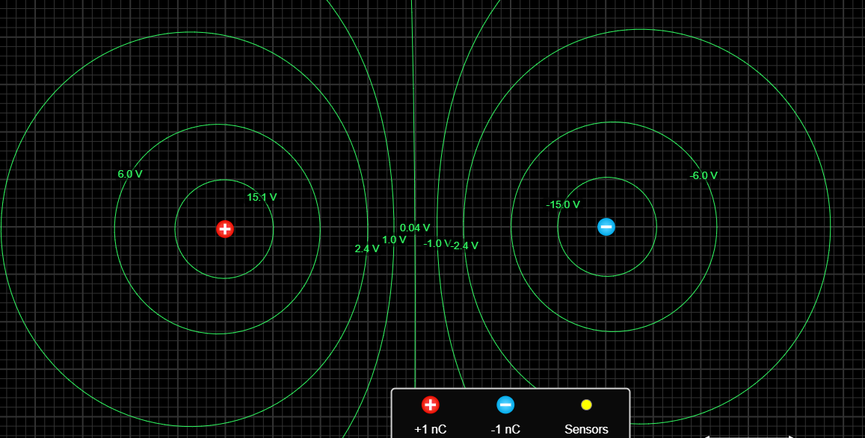

Part 2: Field lines for a parallel conductor plate (parallel plate capacitor)

Step 2)
a) How many field lines are there?
Number of field lines = 13
b) Is the density of the field lines constant?
Yes, the density of the field lines is constant.
c) What does this tell you about the intensity of the electric field for all points between the parallel plates?
Thus, if the density of the field lines is constant then the intensity of the electric field for all points between the parallel plates also remains uniform as they are directly proportional.
d) The expectation of how the equipotential surfaces would look like:
Here electric field lines are always perpendicular to equipotential surfaces, thus equipotential surfaces must be plane surface.
e) Which equipotential surface will have the highest electric potential?
The potential is greatest near the positive charge.
f) Which equipotential surface will have the lowest electric potential?
The potential is lowest near the negative charge.

Step 3)
a) Does the density of the field lines increase?
When the charge of the battery is increased, the density of the field lines also increases.
b) What does this tell you about the intensity of the electric field between the plates now?
From the above it is clear that the charge and the electric field lines are directly proportional, hence whenever the electric-field increases the intensity also increases.
Step 4)
a) What happened to the direction of the electric field now?
The direction of the electric field gets reversed (opposite direction).
b) Which surface at or between the plates will have the largest electric potential and
The surface near the positive charge will have the largest electric potential.
c) Which will have the lowest electric potential?
The surface near the negative charge will have the lowest electric potential.
Step 5) after you watched the video, were your answers correct for step (2): b) and c) and for step (3): a) and b)? Explain.
The video provides a clear idea about the parallel plate conductors and almost the answers were correct.

Part 3: A spherical conductor and oppositely charged conductor plates
Step 2)
Which diagram (a, b, or c) correctly represents the field lines? Explain why?
Figure a) represents the field lines for a neutral conductor sphere placed between two oppositely charged parallel plates. Because in this figure the electric field between parallel oppositely charged plates is uniform in the central region.

Part 4: A circular conductor and one conductor plate that are oppositely charged
Step 2)
For the photo in fig. 5, what do you notice about the electric field inside the cylinder?
The electric field inside the cylinder is of high intensity.
Step 3) for the photo in fig. 5, what do you notice about the angle between the electric field line and each point on the surface of each conductor?
The angle between the Electric field and an equipotential surface is always 90. This is because, when the potential becomes constant, the negative potential gradient also becomes zero, hence necessitating the need for the Electric field to be always normal with the surface.
Step 4)
For fig. 6, a) Are the field lines perpendicular to the points of the surfaces of the conductors?
The field lines are perpendicular to the points of the surfaces of the conductor.
b) For fig. 6, would the equipotential line between points A and B be horizontal and parallel to the rod? Why?
The equipotential line between points A and B may be horizontal and parallel to the rod as the charges are free to move on a conductor, the electric field near a conductor is perpendicular to the conductor's surface.
c) For fig. 6, c) Will the equipotential between points C and D be a curve? Why?
The equipotential between point C and D be a curve, given there is no flow of charge being exchanged between the two points within or at the surface of a given conductor.

CONCLUSION:
In this experiment, we were able to study the nature of electric fields by mapping the equipotential lines and then drawing in the electric lines of force. Also, it is observed that the potential difference along an equipotential line is zero because the force component is zero.

